Hadoop Average Temp Outputs:

1. Start the Hadoop cluster

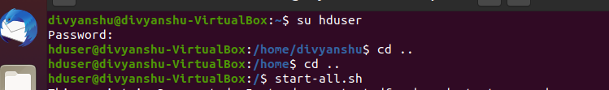

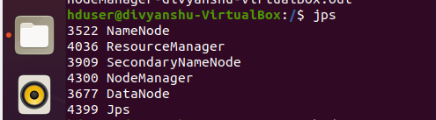

1. Copy binary file to Hadoop file system and see the location

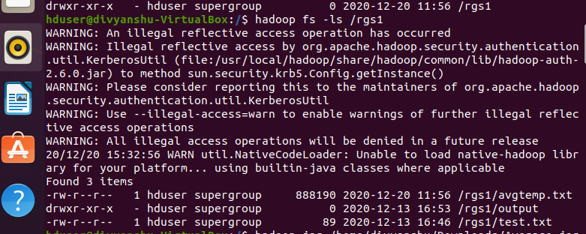

1. Running Average.jar



1. Results

